Institute of Information Technology (IIT)

Jahangirnagar University



**Lab Report: 09**

Submitted by:

Name: Md. Shakil Hossain

Roll No: 2023

Lab Date: 30-08-2023

Submission Date: 11-09-2023

# EXPERIMENT NO: 09

**NAME OF THE EXPERIMENT**

Audio Data Handling in MATLAB

# OBJECTIVE

1. To acquire proficiency in MATLAB for reading various types of audio files (e.g., WAV, MP3) and understanding their data representation.
2. Develop the ability to record and save sound or speech using MATLAB, while understanding the fundamentals of sampling rates and signal quality control.

# APPARATUS

1. MATLAB
2. Recorder

# THEORY

In MATLAB, audio file reading is the process of importing and interpreting audio data from formats like WAV or MP3. It allows for data extraction, analysis, and manipulation. Audio data is represented as discrete samples capturing sound wave amplitudes at regular intervals.

MATLAB's built-in functions like audioread() facilitate loading audio data and accessing metadata like sampling rate and duration, serving as a foundation for signal processing and analysis. Additionally, MATLAB offers voice recording capabilities through functions like audiorecorder(), enabling real-time capture of sound or speech, opening doors to applications like voice recognition and audio research.

# PROGRAM

## Read Audio Files in Matlab.

clc;

clear;

close all;

% read .wav file

[data,fs] = audioread('shakil.wav');

% read .mp3 file

[x, fs1] = audioread('shakil.mp3');

% play audio files

sound(x,fs1); %one method

% play audio files by another method

player = audioplayer(x,fs1);

play(player);

pause(5);

pause(player);

pause(5);

stop(player);

% plot signal

plot(x);

title('Input Sound File');

## Record Speech/Sound in Matlab.

clc;

clear;

close all;

recObj = audiorecorder;

recDuration = 10; % will record for 10sec. for this command pause needs to be added

% start recording

disp("Begin speaking.")

recordblocking(recObj,recDuration);

% stop recording

disp("End of recording.")

% Play recorded sound

play(recObj);

% get audio data

y = getaudiodata(recObj);

% plot the sound

plot(y);

# 

# RESULT

## Read Audio Files in Matlab.

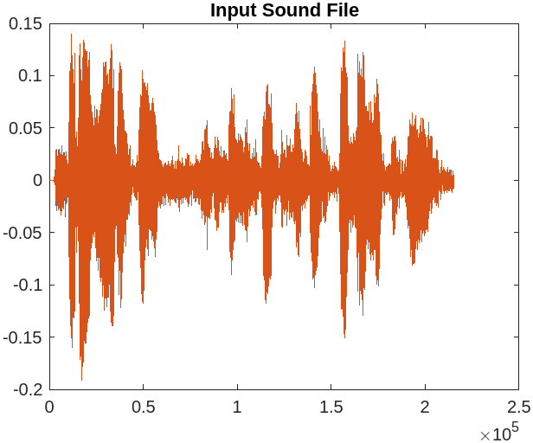

**Figure: input sound file signal Record Speech/Sound in Matlab.**

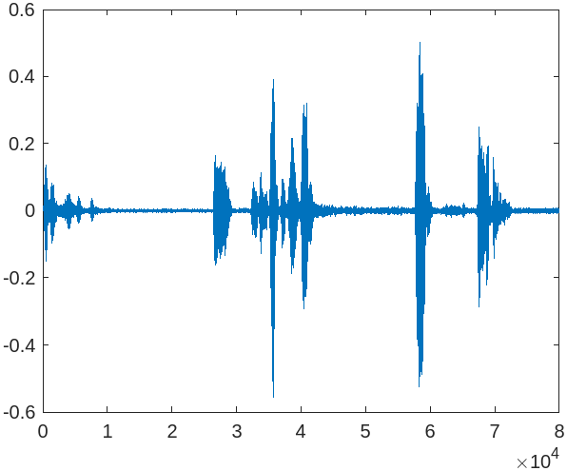

**Figure: recorded audio signal**

# DISCUSSION

This experiment shows the acquisition of a deep understanding of data representation, encompassing tasks such as exploring file properties and visualizing audio waveforms. We also delved into voice recording using MATLAB, where we became adept at configuring input devices and optimizing recording parameters. This practical experience has significantly expanded our capabilities for real-time sound or speech capture and storage, providing a solid foundation for various applications in the field.

# CONCLUSION

Mastering audio file handling and voice recording in MATLAB equips us with valuable skills for working with audio data in various domains, from music analysis to speech recognition. These foundational techniques pave the way for more advanced experiments and projects that rely on audio processing and analysis within the MATLAB environment.

# REFERENCE

**[1]** JAGADISH CHANDRA BOSE RESEARCH ORGANISATION,

Available: https:/[/www.jcbrolabs.org/spe](http://www.jcbrolabs.org/speech-processing)e[ch-processing [A](http://www.jcbrolabs.org/speech-processing)ccessed: September 9, 2023]